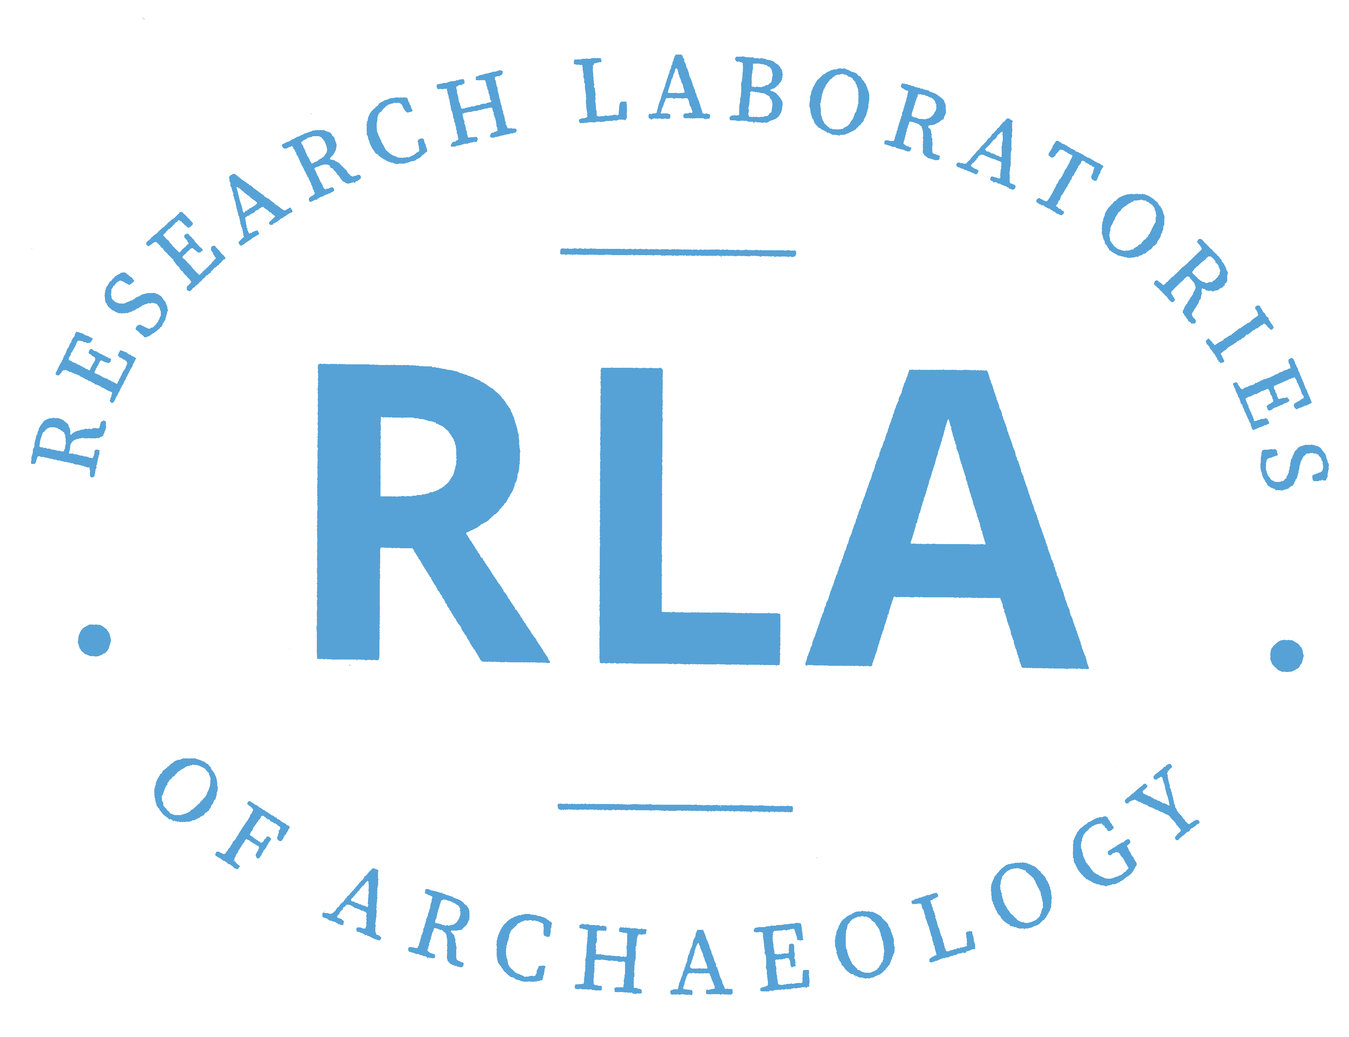

SEAC 2019 – RLA Faculty and Student Presentations (Listed in Order of presentation)

Thursday – November 7

8:00 R.P. Stephen Davis, Larry R. Kimball, Timothy J. Bauman, Lynne P. Sullivan “Jefferson Chapman the Archaeologist and Museum Director” in Backhoes & Trowels: Some Contributions to Southeastern Archaeology by Jefferson Chapman and Friends, Part 1 (Windsor I)

9:40 Gabrielle Purcell “Sweet Potatoes on Cherokee Sites: A Closer Look Using SEM Analysis” in Backhoes & Trowels: Some Contributions to Southeastern Archaeology by Jefferson Chapman and Friends (Winsor I)

10:40 Vincas P. Steponaitis, Vernon J. Knight, George E. Lankford “A New Look at Effigy Pipes from the Trans-Mississippi South” in Mississippian Studies (Windsor II)

1:40 Cayla Colclasure “Guale Foodways and Marine Invertebrates During the Mission-era on St. Catherine’s Island, Georgia” Colonial and Historic Period Studies (Winston I and II)

Friday- November 8

9:40 Anna Graham, Ashley Peles, Vincas Steponaitis, John O’Hear, “Exploring Coles Creek Mound Site Activities Through Pit and Midden Features” In Current Research in Mississippi Archaeology/New and Ongoing Research Directions in Mississippi Archaeology, Part I (Surrey I and II)

1:00 Erin B. Spicola, Arielle M. Pierson, Anna F. Graham, Megan C. Kassabaum “Exploring Familiar Landscapes: From Discovery to Display in Wilkinson County” in Current Research in Mississippi Archaeology/New and Ongoing Research Directions in Mississippi Archaeology, Part II (Surrey I and II)

3:00-5:00 Grace E. Riehm, Vincas P. Steponaitis, Joseph V. Frank III, Ethnohistoric and Archaeological Evidence on the Locations of the Natchez Villages (Poster) In Late Pre-Contact and Early Contact: Mounds, Villages, Symbols (Mezzanine)

3:00-5:00 Chris Rodning, David Moore, Robin Beck, Rachel Briggs, Abra Meriweather, Architecture of the Burke Phase: Late Mississippian and Protohistoric Structures in the Western North Carolina Piedmont (Poster) In Late Pre-Contact and Early Contact: Mounds, Villages, Symbols (Mezzanine)

Saturday – November 9

8:40 Madelaine Azar “Making Heads or Tails: An Iconographic Analysis of Rim Effigy Bowls from the Central Mississippi River Valley” in Ceramics and Iconography (Windsor IV and V)

