MODERN PRIMATES AND HUMANS
RECITATION SECTION WORKSHEET

This worksheet accompanies material covered in recitation and on the Anth 148: Humans Origin website at https://archaeology.sites.unc.edu/anth-148-human-origins.

STATION 1: NON-PRIMATE MAMMALS
Species represented: Beaver, Coyote, Mink, Muskrat, Raccoon plus Human
- Compare the mammal skulls to the human skull. What differences can you observe in the sensory apparatuses (e.g., eyes, snout, etc.)? What do these differences suggest about sensory reliance among these different species?

- Examine the dentition of the mammals. Which species have specialized dentition? What are the functions and adaptive benefits of dental specialization?

- Look at the differences in the position of the foramen magnum (the large opening at the base of the skull) of the mammal skulls and human skull. How does its positioning relate to locomotion?

STATION 2: LOCOMOTION
Species represented: Human, Chimpanzee, Cat
- Examine the human, chimpanzee, and cat pelvises. Compare the shape of the ilium and acetabulum on each species. What differences do you observe? What do these differences suggest about locomotion?

- Examine the human and chimpanzee femurs. What differences can you observe? [Hint: consider the bicondylar angle.] How do these differences function in bipedalism?

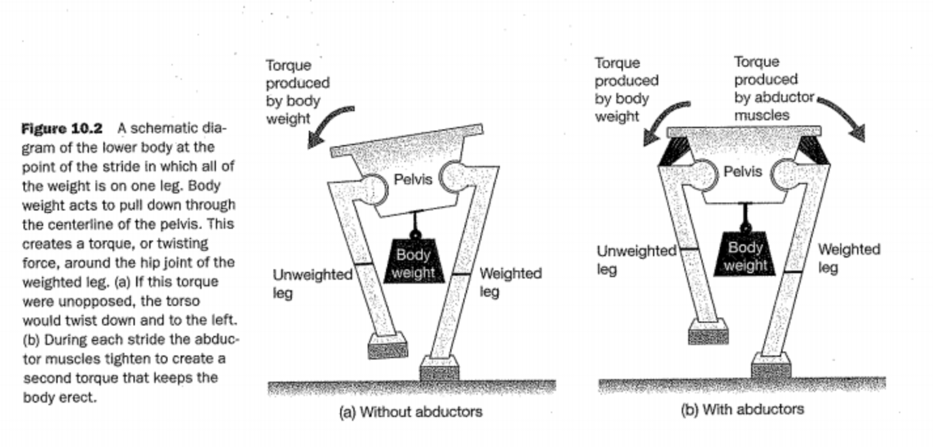
(Image from Chapter 10 in How Humans Evolved by Boyd and Silk that shows how the muscle attachments from the flared shape of the pelvis to the elongated femoral neck is important in bipedalism in humans.)
STATION 3: PRIMATE TAXONOMY — STREPSIRRHINE VS. HAPLORRHINE and PLATYRRHINE VS. CATARRHINE
Species represented: Ringtail Lemur, Tarsier, Baboon, Macaque, Owl Monkey, Orangutan
- What differences do you see between the strepsirrhine and haplorrhine skulls? What does this suggest about sensory reliance?
Strepsirrhines | Haplorrhines

- While the tarsier is now grouped with the haplorrhines (according to the revised primate taxonomy), what are some of its skeletal features that are more similar with strepsirrhines?

- Which of the haplorrhines at this station are platyrrhines (new world monkeys)? Which are catarrhines (old world monkeys)? What are some of the morphological differences you see between platyrrhines and catarrhines?
Platyrrhine | Catarrhine

STATION 4: THE GREAT APES
Species represented: Chimpanzee, Gorilla (male and female), Human
- Examine the dentition of these three species. Do primates tend to have a greater or lesser degree of dental specialization than other mammals? What are the dental formulae of these species?

- Do any of these species have a skeletal feature that reflects dietary specialization? If so, please explain.

- Compare the male gorilla skull to the female gorilla skull. Describe the differences in morphological features and how they represent sexual dimorphism.

